**MASTERS DOCUMENTATION**

|  |  |
| --- | --- |
| **Application :** | NGERP |
| **Workflow :** | MASTERS |
| **Workflow Item Name :** | Tax Category |

**Description :**

Tax Category Master is Used to Create Tax Category.

**Workflow Process :**

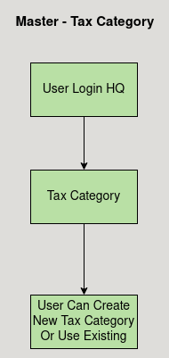

**Business Rules :**

* The Tax Category Master is used to create tax category.
* Tax Category can be only created in HQ.
* Tax Category should be Active to show in the tax category list.
* Tax Category Must be assigned to Tax Rate to calculate Tax.